

BANKING CONSULTANCY

Software Requirement Specification

Project Code: PCBC001
Document Code: SRS_BC – v0.1

HCM City, 15/01/2013

Record of change

*A - Added M - Modified D - Deleted
Effective Date | Changed Items | A*  M, D | Change Description | New Version
15/01/2013 | Initial | A | Add Introduction | 0.1
24/02/2013 | Overall Description | A | Add overall description, 3 functions | 0.2
28/02/2013 | Functional, non-functional | A,D | Add non-functions, add more 2 functions, add sequence diagram | 0.2

SIGNATURE PAGE

ORIGINATOR: Nguyễn Phan Anh 15/01/2013
Lê Phước Việt
Nguyễn Anh Tuấn
Đường Huy Hoàng
Võ Công Đoàn
REVIEWERS: Lâm Hữu Khánh Phương <Date>

APPROVAL: Lâm Hữu Khánh Phương <Date>

TABLE OF CONTENTS
1 Introduction 5
1.1 Purpose 5
1.2 Scope 5
1.3 Definitions, Acronyms, and Abbreviations 5
1.4 References 6
1.5 Overview 6
2 Overall Description 8
2.1 Product perspective 8
2.2 Product functions 8
2.3 User characteristics 8
2.4 Constraints 8
2.5 Assumptions and dependencies 8
2.6 Requirements subsets 8
3 FUNCTIONAL Requirements 9
3.1 Update database 9
3.2 View information and calculate money 9
3.3 View top highest interest rate banks 11
3.4 Calculate interest rate 11
4 Uscase model 12
4.1 <Use Cases Diagram> 12
4.2 <Use Cases’ Details> 12
4.3 <Functional Requirement one> 12
5 NON-FUNCTIONAL Requirements 15
5.1 Usability 15
5.2 Reliability 15
5.3 Performance 16
5.4 Supportability 16
5.5 Design Constraints 16
5.6 On-line User Documentation and Help System Requirements 16
5.7 Purchased Components 17
5.8 Interfaces 17
5.9 Licensing Requirements 17
5.10 Legal, Copyright, and Other Notices 17
5.11 Applicable Standards 17
6 Supporting Information 19

Introduction

Purpose
This document formally describes the software requirement specification of the Banking Consultancy. It will explain the purpose and features of the system, the interfaces of the system, and what the system will do, also describe non-functional requirements, design constraints.

Scope
The software includes 3 main parts.
- The homepage website: This website will collect the information of all banks in a specify area (example in Vietnam). The website shows the list of all banks which are collected. The website has a link for user to download the Client Program (CP) to install on user mobile.
- The web service: this web is invisible with the user. It’s a bridge between homepage website and the CP. The CP will get the information from homepage website through this web service.
- The Client Program: This is the program will be installed on user mobile. The CP requires android OS. The user will interact almost with this software by the CP. The CP will get information of banks from web service and help the user work out the interests, estimate the time which the user need to wait to have their wanted money, list the top 10 banks have the highest interest to help the user easily choose the best bank.

Definitions, Acronyms, and Abbreviations
Definitions
Client Program | This is a module of software. It will be installed on the user mobile. This module requires the mobile run on Android OS.
Abbreviations
URD | User Requirements Document
OS | Operating System
GUI | Graphic User Interface
CP | Client Program

References
- http://en.wikipedia.org/wiki/
- URD Template on http://cms-hcm.fpt.edu.vn

Overview
This SRS contains 6 sections:
- Section 1 – Introduction: This section introduce generally about this document and this software. It includes purpose of SRS; the scope of software; definitions, acronyms and abbreviations in SRS; list of all reference document or website; and the overview to list all sections in this SRS.
- Section 2 – Overall Description: It includes product perspective, product functions, user characteristics, constraints, assumptions and dependencies, requirements subsets. This section describes the general factors that affect the product and its requirements. This section does not state specific requirements. Instead, it provides a background for those requirements, which are defined in detail in next section, and makes them easier to understand.
- Section 3 – Functional requirements: This section describes detail of all software’s functions. There are 3 main functions and an extra function. In the main function Calculate, there are 2 options for user: calculate the money and range time.
- Section 4 – Use case model: This section represents the use case diagram of the software. It includes the Actors that interact with the system and the Use Cases that describe these interactions.
- Section 5 – Non – functional requirements: This section describes the non-functional requirements of the system. It includes usability, reliability, performance, supportability, etc.
- Section 6 – Supporting information: This section describes the supporting information to make the SRS easier to use. It includes an interface diagram. It makes users easier to view the relative interfaces.

Overall Description

Product perspective
User can use all function supported by software to get information about banks with related information such as interest, contact information… Besides, software use these information to automatically give users advices that help them to choose appropriate bank.

Product functions
The software includes main functions below:
- Update database: use internet connection to connection to server to update database.
- View information and calculate money:
  - View information: provide all of related information about the bank.
  - Calculate money: calculate sum of money that depositor will receive from input

User characteristics
- Casual user: the normal users who have not much knowledge of Android device.
- Power user: the users that have a lot of experience about using Android device.

Constraints
Run on Android 2.2 device, internet connection (for updating database).

Assumptions and dependencies

Requirements subsets

FUNCTIONAL Requirements

Update database
This function supports users for update information from server in order to make sure information is always up to date.
This function will check the internet connection or not. If device can connection to server, it get version in database and send it through internet to server. The server is responsible for compare version on server with version in database, if they are same, return true, or not, return false and update database that stored in device again.
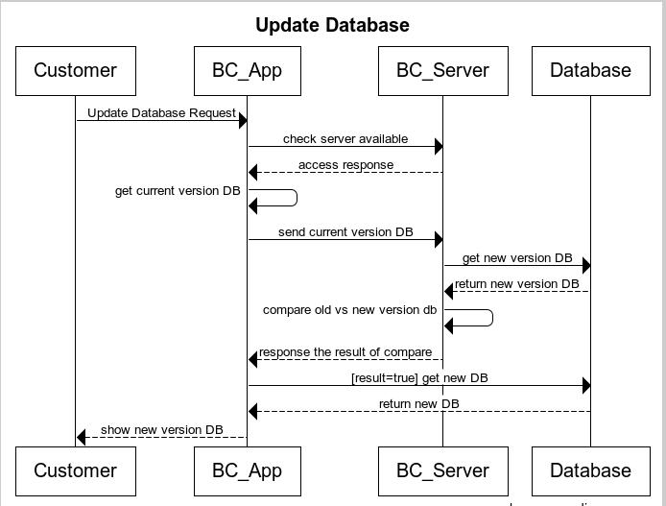
Figture 1 - Update Database Sequence diagram

View information and calculate money
This function provide all of related information of banks in list and support users calculate sum of money that depositor will receive from input.
The users choose one bank in list, and there’re 2 sub-function below:
View information: provide all of related information of bank in list: short name, full name, address, phone, fax, homepage, description (optional).
Calculate money: the uses will choose interest (annual rate – load from database), deposit. The software bases on these input and calculate sum of money that depositor will receive
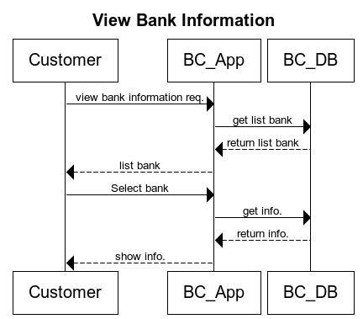
Figure 2 - View Bank Sequence Diagram
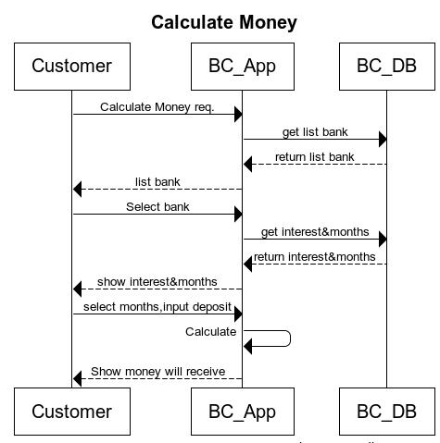
Figure 3 - Calculate Money Sequence Diagram

View top highest interest rate banks
This function provide top 10 banks that have highest interest rate to help the user easy to choose the suitable bank.
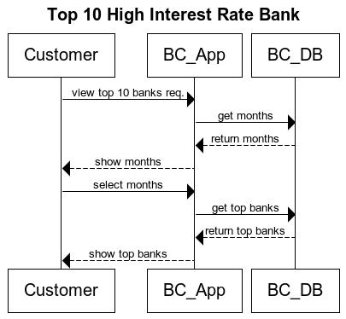
Figure 1 - Top 10 high rate interest Bank

Calculate interest rate
This function help the user calculate the interest rate least to have the money will receive after number of months. The user input the deposit and the money will receive, and number of months, the application will calculate and show to user the least interest rate that user need.
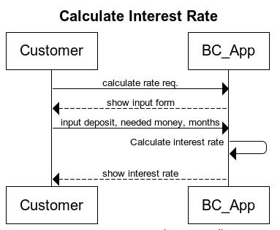
Figure 5 - Calculate Interest Rate Sequence Diagram

Uscase model
[The Use Case Model defines the behavior of the system (functional specification) from the users’ perspective. It includes the Actors that interact with the system and the Use Cases that describe these interactions.]

<Use Cases Diagram>
[The main Use Case Diagrams of the system]

<Use Cases’ Details>

<Functional Requirement one>

Update database

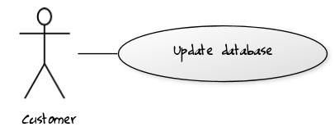
Use case name | Update database
Related Requirements | Requirement A.1.
Goal In Context | Make database is up-to-date
Preconditions | Internet connection require.
Successful End Condition | Database is up-to-date
Failed End Condition | Database is not updated.
Primary Actors | User
 | Secondary Actors
 | Trigger
Main Flow | Step | Action
 | 1 | In main screen, click button “Cập nhật dữ liệu”
 | 2 | The database is updated, and the status will show below.

View information
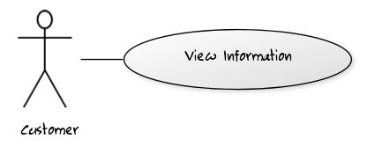
Use case name | View information
Related Requirements | Requirement A.1.
Goal In Context | View information of banks
Preconditions | Database is not empty
Successful End Condition | List of banks will be shown
Failed End Condition | List is empty
Primary Actors | User
 | Secondary Actors | Author Credentials Database.
 | Trigger
Main Flow | Step | Action
 | 1 | In main screen, click button “Xem danh sách ngân hàng”
 | 2 | The list of banks will be showns, click button “Xem thông tin” belong to your bank
 | 3 | The information of specific bank will be shown

Calculate Money
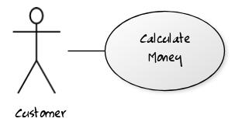
Use case name | Calculate money
Related Requirements | Requirement A.1.
Goal In Context | Calculate money
Preconditions | Database is not empty
Successful End Condition | The amount of money will be shown
Failed End Condition
Primary Actors | User
 | Secondary Actors | Author Credentials Database.
 | Trigger
Main Flow | Step | Action
 | 1 | In view infomation screen, click button “Tính tiền” (belong to your bank)
 | 2 | Other screen will be shown, choose “Gói lãi suất”, type the deposit into “Tiền gửi”
 | 3 | Click button “Tính tiền”
 | 4 | The amount of money that user will receive is calculated and shown below.

View Top Bank
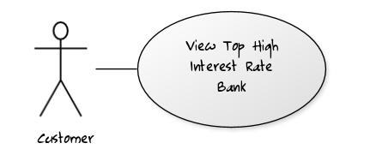
Use case name | View Top Bank
Related Requirements | Requirement A.1.
Goal In Context | List top 10 bank with highest interest
Preconditions | Database is not empty
Successful End Condition | List of 10 bank with highest interest will be shown
Failed End Condition | Show nothing.
Primary Actors | User
 | Secondary Actors
 | Trigger
Main Flow | Step | Action
 | 1 | In main screen, click button “Xem danh sách ngân hàng theo lãi suất”
 | 2 | The other screen will be shown, choose “Gói lãi suất” and click on button “Top 10 ngân hàng”
 | 3 | The list of 10 banks with highest interest (belong to interest type the user choose) rate will be shown.

Calculate interest rate
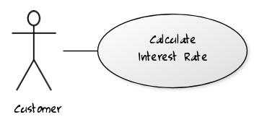
Use case name | Calculate interest rate
Related Requirements | Requirement A.1.
Goal In Context | Calculate interest rate
Preconditions
Successful End Condition | The interest rate will be shown
Failed End Condition | Show nothing.
Primary Actors | User
 | Secondary Actors
 | Trigger
Main Flow | Step | Action
 | 1 | In main screen, click button “Tính lãi suất”
 | 2 | The other screen will be shown, type the deposit into “Tiền gửi”, the money user will receive into “Tiền nhận”, the time into “Tháng” (month).
 | 3 | Click on button “Tính lãi suất”
 | 4 | The interest rate will be calculated and shown below.

NON-FUNCTIONAL Requirements

Usability
- Users do not take much time to make it easy for using this software.
- Support Vietnamese language interface
- A survey after 1 week of use should reveal that at least 90% of users were satisfied with interface of this software.
- Measurable task time: less than 0.5s (make sure for all tasks)

Reliability
- Rate of failure occurrence must be ensured less than 0.001%.
- Mean Time Between Failure (MTBF): 2 years.
- Mean Time To Repair (MTTR): 1 week.

Licensing Requirements
- This software is distribute with FREE license.

Legal, Copyright, and Other Notices
- Do not redistribute without permission or for any commercial purpose
- This software is distributed with FREE license on Google Play (https://play.google.com/store)

Applicable Standards
[This section describes by reference any applicable standard and the specific sections of any such standards which apply to the system being described. For example, this could include legal, quality and regulatory standards, industry standards for usability, interoperability, internationalization, operating system compliance, and so forth.]

Supporting Information
[The supporting information makes the SRS easier to use. It includes:
Table of contents
Index
Appendices
These may include use-case storyboards or user-interface prototypes. When appendices are included, the SRS should explicitly state whether or not the appendices are to be considered part of the requirements.]

